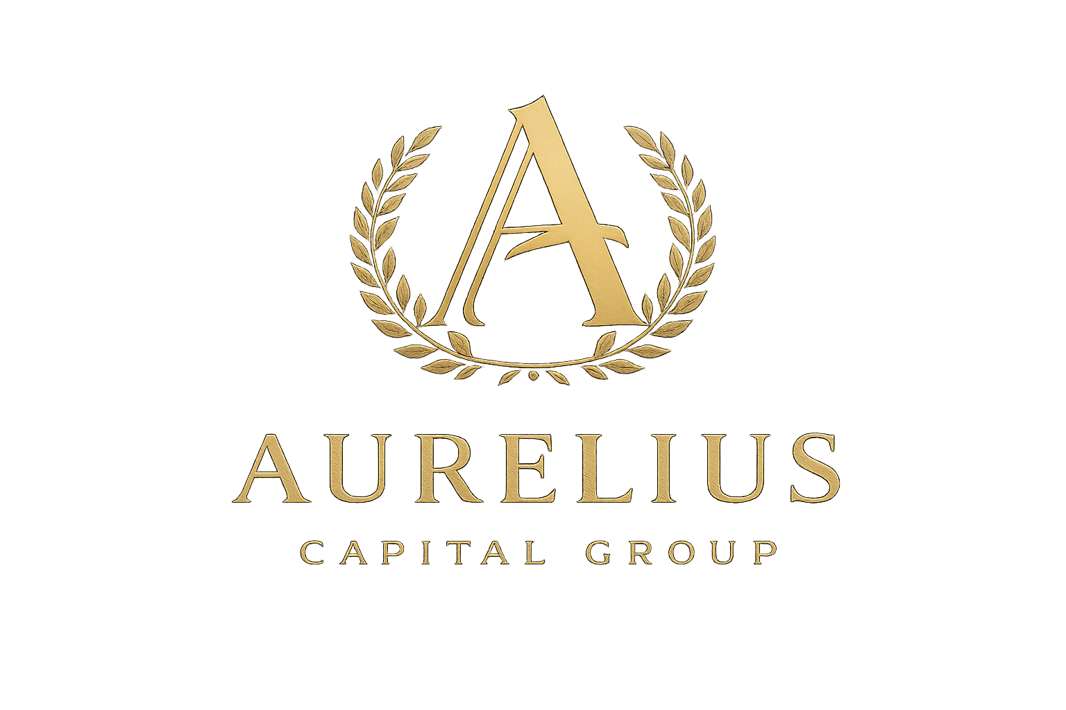
AURELIUS CAPITAL GROUP

SALES & CONSULTANT COMPENSATION FRAMEWORK

Commercial Real Estate Origination
Effective Date: [Insert Date]
Applies To: Independent Sales Consultants & Deal Originators

1. PURPOSE
This document outlines the compensation structure for independent sales consultants, advisors, and originators (“Consultants”) who source commercial real estate assets that successfully transact through Aurelius Capital Group (“ACG”).
ACG operates a success-only, performance-based model. Consultants are compensated only when a transaction closes.

2. ROLE OF THE CONSULTANT
Consultants are responsible for:
- Identifying potential commercial real estate assets
- Introducing asset owners to ACG
- Facilitating initial engagement between the owner and ACG
Consultants do not:
- Provide investment advice
- Negotiate transaction terms
- Interface directly with tokenization platforms unless authorized
- Represent ACG legally or contractually
All structuring, screening, and execution is handled by ACG.

3. COMMISSION STRUCTURE (50% OF ACG FEES)

Commission Rate
Consultants earn 50% of the cash success fee received by ACG for transactions directly attributable to their sourced asset.
- No caps
- No quotas
- No retainers
- No commissions unless the deal closes

4. PAYMENT TRIGGER
A commission is earned only upon a Successful Transaction, defined as:
- A closed tokenization, capitalization, or liquidity event
- Where ACG receives its cash success fee
Consultant commissions are paid only after ACG has received cleared funds.

5. NUMERICAL EARNINGS EXAMPLES

Example 1: $2,000,000 Property (Standard Case)
Item | Amount
Asset Value | $2,000,000
ACG Success Fee (2.5%) | $50,000
Consultant Commission (50%) | $25,000
One deal = $25,000 paid to the Consultant

Example 2: $5,000,000 Property
Item | Amount
Asset Value | $5,000,000
ACG Success Fee (3.0%) | $150,000
Consultant Commission (50%) | $75,000
One deal = $75,000

Example 3: Multiple Deals Per Year
Deals Closed | Avg Deal Size | Consultant Earnings
2 deals | $2M | $50,000
4 deals | $3M | $150,000
6 deals | $5M | $450,000
Top performers can generate six-figure income without exclusivity.

6. TIMING OF PAYMENT
- Consultant commissions are paid within 10–15 business days after ACG receives its success fee
- Payments are made via wire, ACH, or other agreed method
- No advances or draws are provided

7. DEAL ATTRIBUTION & PROTECTION
- Consultants must introduce assets in writing (email or CRM confirmation)
- ACG confirms attribution before proceeding
- If multiple consultants introduce the same asset, first documented introduction prevails
- Circumvention by asset owners is protected under ACG’s mandate agreements

8. EXCLUSIONS
Consultants are not entitled to:
- Equity or token allocations retained by ACG
- Ongoing management fees
- Residual income unless separately agreed
(Equity participation may be offered in rare strategic cases, at ACG’s discretion.)

9. INDEPENDENT CONTRACTOR STATUS
Consultants act as independent contractors, not employees, partners, or agents of ACG.
Consultants are responsible for:
- Their own taxes
- Licensing (if applicable)
- Compliance with local laws

10. TERMINATION & SURVIVAL
- Either party may terminate the relationship at any time
- Commissions survive termination only for deals already under mandate and introduced prior to termination

11. WHY THIS MODEL IS ATTRACTIVE
- No cold calling quotas
- No administrative burden
- No execution risk
- No capital required
- High-dollar commissions per deal
One good property can equal a year’s income.

12. FINAL STATEMENT
“If you can bring real, income-producing commercial properties, we will do the rest. When the deal closes, you get paid — materially.”

